1. When you increase the multiplying factor for both the classes the data is very abrupt i.e. very high variance and its not possible to classify the data linearly as shown in below figure

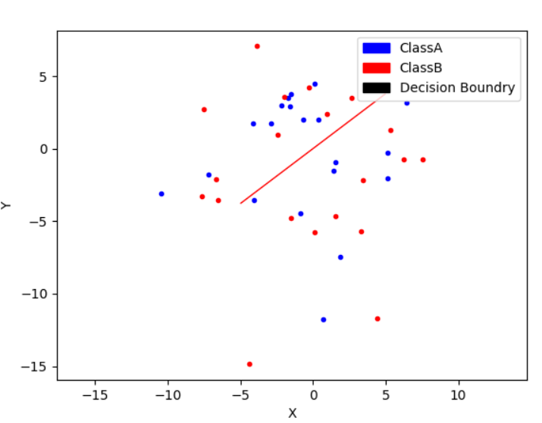

1. Data classified with Polynomial (2)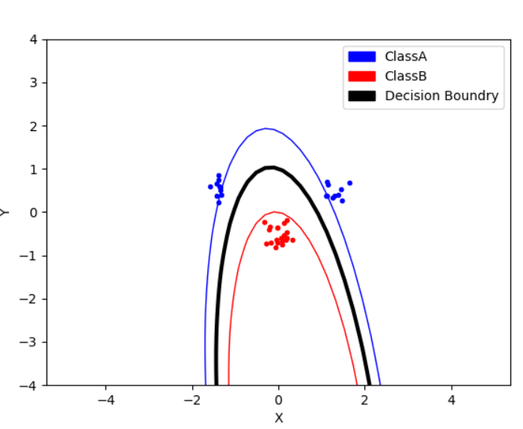Data Classified with Polynomial (3)  
   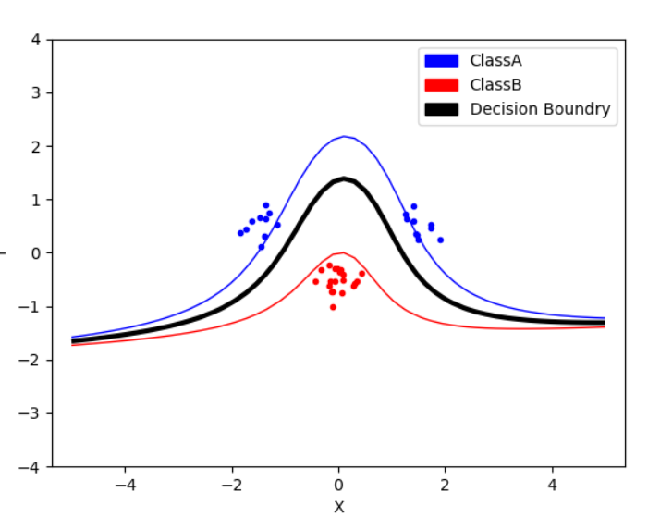

Data Classified with RBF

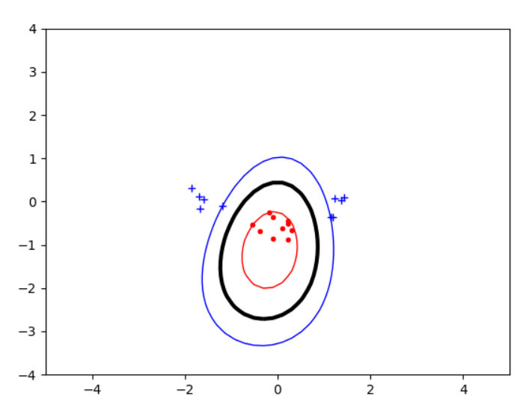

1. By varying some of these parameters we can make the model fit more closely or more loosely the dataset. If we increase the sigma of the radial kernel, for example, we obtain a smoother curve and increase the bias of the model while decreasing the variance. On the other hand, if we decrease sigma we obtain a classification that tends to be more "edgy" and overfit the data (hence increase variance).  
     
   While the parameter p in polynomial kernel control the degree and if we increase it the decision boundary becomes thinner.
2. The variable C represent a sort of tolerance for data points which are not correctly classified. If the value of C is high it means that we want to minimise the effect of Slack Variables while if the value is low (min 0) it means that the model allows for a great number of miss-classified points.

Slack Variables are useful when a small number of points, often considered noise, prevents the classification of simple underlying model. SVM, in fact, are not made to take in consider classification in a statistical way, where a model can reach a certain accuracy depending on how many points are correctly classified. They are only able to neatly divide two datasets optimizing for the "largest street". Hence the importance of Slack variables to make the technique more usable. It is important still to remember that Slack variables are a trade-off on the accuracy of the model.

1. Depends on the data class. If there is too much noise present in the data then it makes sense to use polynomial or RBF kernel for the classification. If there is less noise we can use slack variables but it totally depends on the rate of misclassification in the data class.